**SEWER CLEANING**

**Combination Sewer Cleaners**

**1**

**Truck Mounted Jetters**

**2**

**Combination Sewer Cleaners**

Combination sewer cleaners provide contractors and governments with excellent jetting action and superior vacuum power to efficiently open clogged sewer lines and perform needed maintenance.

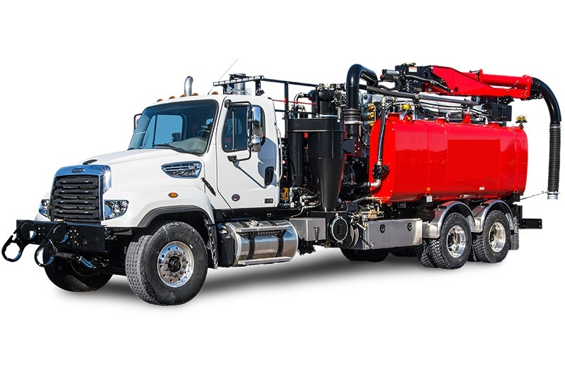

**Features**

**Power Module**

* Range of power module packages based on customer need
* Positive displacement blowers from 16 inches to 27 inches hg of vacuum power
* Jetting systems complement the cleaning power with capacity ranges from 50 to 120 gpm and pressures to 3000 psi
* All Smart Flow, smart controls system standard
* Single engine operation reduces fuel consumption emissions, noise and maintenance

**Hose Reel**

* Axial pivoting hose reel is easily fixed into multiple positions for efficient operation
* Unique, heavy-duty direct reel drive system consists of a rugged planetary gear box, driven by a hydraulic motor incorporating a cross port relief valve to cushion the system
* Dual latching system means there are no pin alignment problems common to other machines
* Models are available with the operator station at the front or rear of the chassis

**Boom**

* Standard boom telescopes, lifts and swings with proportional controls, putting the vacuum power exactly where you need it
* An 8-inch tube moves debris efficiently from nozzle to debris tank

**Debris Collection**

* Dust and mist-laden material is spun out in cyclone separator and collected in a drop box below
* Cleanout doors are located above and below the cyclone

**High-Pressure Water Pump**

* Plunger-style triplex pump delivers a smooth, continuous flow of water
* Pump is capable of flows from 50 to 120 gpm
* Features run-dry prevention technology

**Water Storage Tanks**

* Water tanks have lifetime warranty
* Fabricated with high quality aluminium for extra strength
* Equipped with interior baffles, water tanks are mounted above the rear fenders to avoid damage from road debris
* Tank position creates positive head pressure to the water pump inlet

**Truck Mounted Jetters**

High-performance sewer line maintenance designed to fit tight budgets. truck-mounted high-pressure jetting machines provide a cost-efficient tool to effectively clear blockages and maintain sewer lines. Designed for applications where wastewater recycling or jet/vac sewer cleaning are not required, It delivers excellent jetting power, simplified operation, superior mobility and a longer working life than other truck jetters.

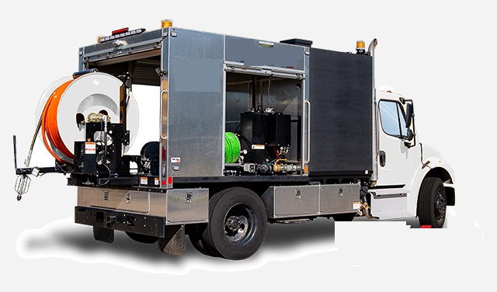

**Features**

**Single-Engine Operation**

* A single engine operates both chassis and jetting system, slashing fuel costs by 40%
* Also reduces harmful emissions and noise

**Controls**

* Smart control system is standard, and protected by a cabinet to avoid damage to levers and joysticks
* Easy-to-understand in-cab controls provide simplified operation

**Hose Reel**

* Hose reel structure hydraulically extends from rear compartment and rotates, locking into position for productive working angles
* Standard reel equipped with 1-inch inside-diameter hose

**Water System**

* Constructed with UV-resistant black polypropylene
* Hydraulically powered triplex plunger pump with different rated capacity
* Dual-fill water system features an ultra-convenient fill port allowing operators to fill tanks from curb or street side of truck

**Rear Compartment**

* Protective rear compartment fabricated with high-strength aluminium protects water pump, hydraulic reservoir, hose reel and plumbing
* Steel subframe with polymer coating maximizes corrosion resistance
* Three anodized aluminium roll-up doors lock to secure all-direction rear compartment access

**All-Weather Operation**

* heater in the rear compartment protects pumps, hoses and plumbing from freezing
* Optional rear canopy shelter shields operators from sun, rain or other elements
* Optional insulation in rear compartment